How to play video and record audio the same time on a PC

# Audio Recording

You can use any recording app you are familiar with. Since we need to do alignment after recording, it is better to select an app with editing ability. I have tried N-track and Audacity and I like Audacity better because it is open source so I can customize it later.

Download Audacity <https://www.audacityteam.org/download/>

Click on "Audacity for Windows" button to download the app

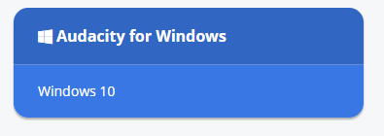

Install Audacity and run. Configure its audio input/output to work with your headphone and microphone. Plug in your earphone and microphone. Click on the red “record” button, make sure your voice can be recorded. You can click on the down-arrow on the right to select the best input available to you.

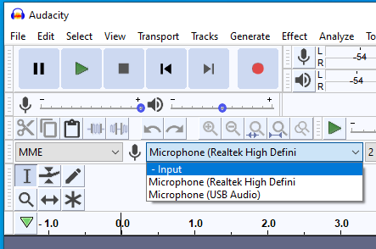

Note: if you use the built-in mic in your earphone, you may need to use a split cable because most old PCs do not support earphone + mic in one jack.

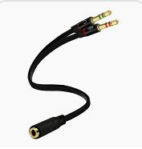

# Video playing

You can use any video player you are familiar with. You can even open the YouTube link of our conductor video and play with your default web browser.

Dry your tears S1+S2: <https://youtu.be/zKHgUTTlEBo>

Dry your tears alto: <https://youtu.be/KUg162q7iBE>

Now you can play video and record audio on a single PC.

# Automated process for computer nerds

Download VLC Media Player: https://www.Click on thvideolan.org/vlc/

Click on the down-arrow on the right of the “Download VLC” button



Then select “Windows 64-bit” if you have a PC that supports 64-bit

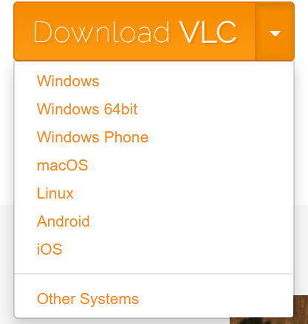

Install VLC Media Player. To play YouTube video, select Media/Open Network Stream...

Then copy and paste the YouTube URL to the textbox and click on Play

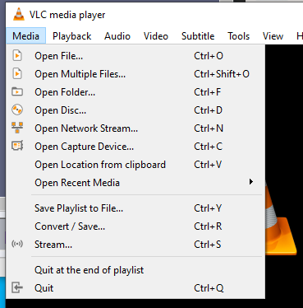

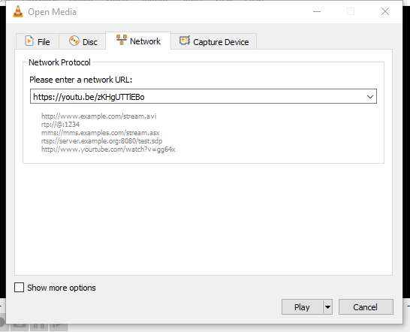

With both Audacity and VLC Media player working, if you want to further save time, here is a way.

Open Audacity. Select Edit/Preferences/Modules and change mod-script-pipe to Enabled, then click on OK. 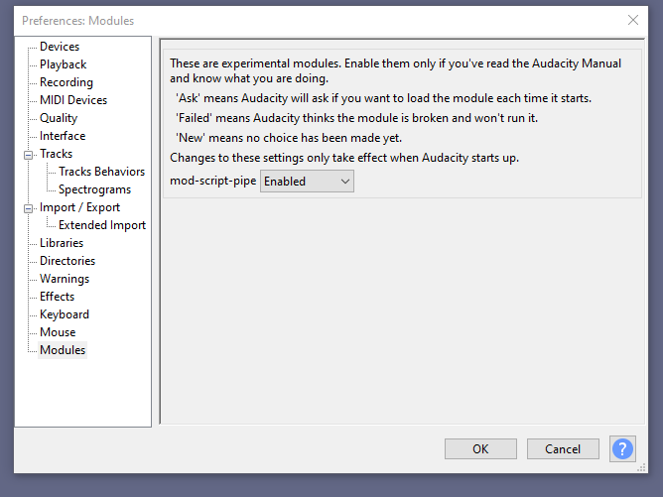

You can also enable the Extra menu in the Interface by checking the checkbox “Show extra menu”:

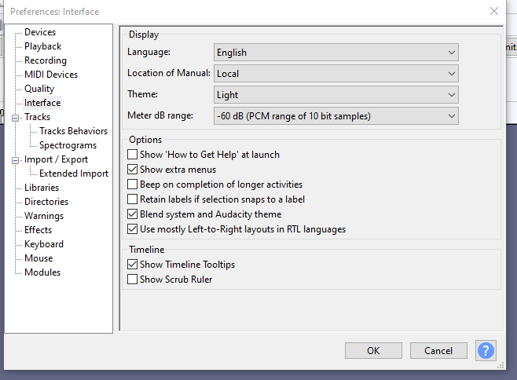

Close and reopen Audacity for this change to take effect.

Now audacity can be controlled by any script-pipe. I use python simply because I already have it installed on my PC.

# Use python to control VLC

Here is the GitHub link of my python script. Currently it only support Windows platform.

<https://github.com/aye98765/Multimedia>